**ENTREPRENEURSHIP**

**MGT401**

**REPORT 2**

**FEASIBILITY ANALYSIS**



**GROUP NUMBER** -1

**SECTION** – S2-S3

**Course In-charge:** Raj K. Kovid Sir

TABLE OF CONTENTS

Introduction 3

Part A: Name of the proposed business 3

part b: name of the founder(s) 3

part c: summary of business 3

PRODUCT/SERVICE FEASIBILITY 4

part a: product/service desirability 4

part b: product/service demand 5

PART C: assessment tools 6

Section 1: concept statement test 6

Section 2: buying intention survey 6

Section 3: conclusion 7

Sub-section 1: PRODUCT/SERVICE DESIRABILITY 8

Sub-section 2: PRODUCT/SERVICE DEMAND 8

Sub-section 3: PRODUCT/SERVICE FEASIBILITY 8

Sub-section 4: SUGGESTIONS FOR IMPROVEMENT 8

INDUSTRY/MARKET FEASIBILITY 9

part a: INDUSTRY ATTRACTIVENESS 9

part B: TARGET MARKET ATTRACTIVENESS 10

part C: TIMELINES OF ENTRY INTO THE TARGET MARKET 10

PART D: CONCLUSION 11

ORGANIZATIONAL FEASIBILITY 12

part a: MANAGEMENT PROWESS 12

part B: RESOURCE SUFFICIENCY 12

PART C: conclusion 13

FINANCIAL FEASIBILITY 15

part a: TOTAL STARTUP CASH NEEDED 15

part B: FINANCIAL PERFORMANCE OF SIMILAR BUSINESSS 16

part C: OVERALL FINANCIAL ATTRACTIVENESS OF THE PROPOSED VENTURE 17

OVERALL FEASIBILITY 18

part a: CONCLUSION 18

**FEASIBILITY ANALYSIS**

***PADHOMITRO***

***MANAGEMENT TEAM***

PadhoMitro is led by its Co-Founders:

1. Kumari Renuka
2. Yash Vaidya
3. Tushar Sharma
4. Shailesh Mohta
5. Rishabh Kumar Kandoi
6. Abhimanyu Kishor Sangitrao

Our platform PadhoMitro provides complete guidance of what all paths can be followed when a person, of any age, is going to start his/her career in any field. Our Platform empowers any individual desirous to learn any subject, by providing a customized inventory of resources (MOOCs, books, websites, blogs, projects, etc.) recommended on the basis of the user’s choice of a subject. He/she will also be provided with help from professionals (will be a paid service) and links to potential recruiters at each and every step to ensure full mentorship and thus making our platform a complete package and also saving their time and energy

from browsing the internet in search for guidance.

Main features of our product include:

1. It gives the user flexibility to learn at a time comfortable for him and with the support of expert mentors to solve his problems at all stages.

2. A pre-planned, well-organized study guide customized accordingly to the user interest and level of expertise in a subject.

3. Full-time Dedicated Mentorship support, in-case of subject/Project related queries

4. A customized road-map to make the user self-sufficient to master a subject without the need to browse the internet.

5. Progress bar that indicates your position with respect to other users for the same subject

6. Giving the user a glimpse from the road-map, as to what will be learned at the end, to enhance curiosity and motivation to learn.

7. Notifications to the user for each new update with regard to course work.

**PART 1: PRODUCT/SERVICE FEASIBILTY**

***ISSUES ADDRESSED IN THIS PART***

1. Product/Service demand
2. Product/Service desirability
3. Conclusion

***ASSESSMENT TOOLS***

***Concept Statement Test***

The concept statement for our product/service idea was prepared and distributed to 5 to 10 people. The following given below shows the results of the survey.

* A sample response to the survey:

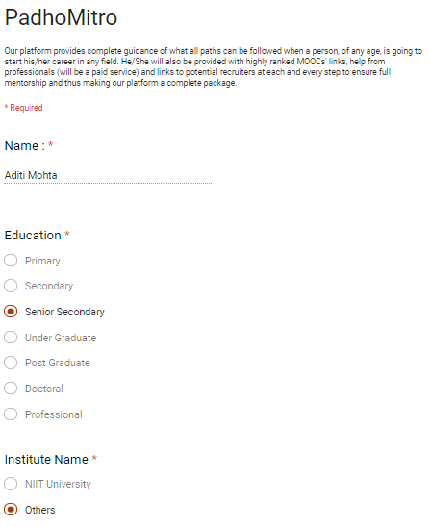

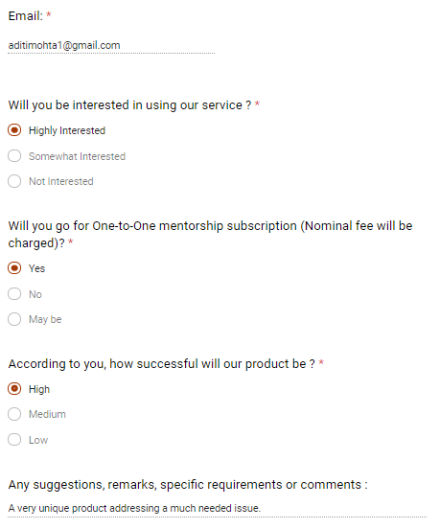

1. **Summarize the information you obtain from the concept statement into the following three categories:**

**Strengths of the product or service idea—things people who evaluated your product or service concept said they “liked” about the idea**

* “provision of a pre-planned, well-organized study guide customized accordingly to the user interest and level of expertise in a subject is unique and will attract a lot of customers especially beginners in any field of study”
* “Option of full time dedicated mentorship for any subject/project related queries and other related guidance is a definite boon”

**Suggestions for strengthening the idea—suggestions made by people for strengthening or improving the idea**

* To guide consumers who want to learn “any new skill/subject” will not be feasible. If the product can offer guidance to selected range of subjects, it is more likely to be feasible and the quality of service will also improve.

**Overall feasibility of the product or service concept—report the number of people who think the idea is feasible, the number of people who think it isn’t feasible, and any additional comments that were made**

* According to our collected responses, **16 out of 23 customers** think that **our idea is feasible** and our product will be highly successful.
* **7 out of 23 thinks otherwise.**

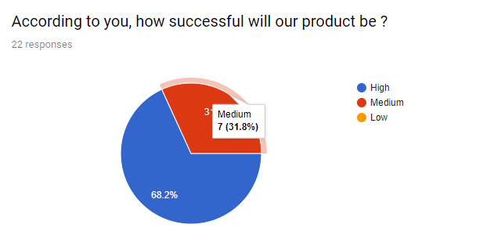

**Other comments and suggestions**

* “The platform caters to services that are really needed by every beginner but not often spoken of.”
* “You should do something in the platform which your competitors do not.”
* “It's a great step, I wish it is helpful to our upcoming generation.”
* “I think this is a good project.”
* “A very unique product addressing a much-needed issue.”

**Buying Intentions Survey**

* Distribute the concept statement to 15 to 30 prospective customers (do not include any of the people who completed the concept statement test) with the following buying intentions survey attached. Ask each participant to read the concept statement and complete the buying intentions survey. Record the number of people who participated in the survey and the results of the survey here.

**The Concept Statement was distributed to 23 prospective customers and conducted a buying intention survey based on it.**

* Along with the raw data recorded here, report the percentage of the total number of people you surveyed that said they would probably buy or definitely would buy your product or service if offered. This percentage is the most important figure in gauging potential customer interest.

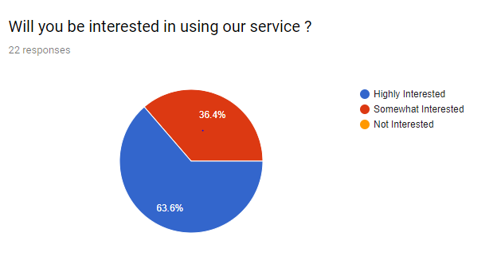

**According to our survey, 63.6% of the total number of people are interested in using our service.**

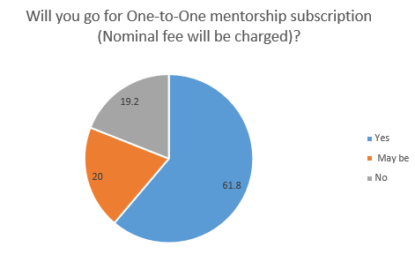

According to our survey, **61.8%** of the total number of people **will** pay for one-to-one mentorship subscription of our service.

According to our survey,**20%** of the total number of people **may** pay for one-to-one mentorship subscription of our service.

According to our survey, **19.2%** of the total number of people **will not** pay for one-to-one mentorship subscription of our service.

***C. Conclusion***

1. Product/service desirability

According to our finding, **63.6% of the total number of people desire our service.**

1. Product/service demand

According to our finding, **31.8% of the total number of people demand our service.**

1. Product/service feasibility: ***FEASIBLE***

According to our finding, **62.8% of the total number of people think our venture is feasible.**

D. Suggestions for improving product/service feasibility.

“If the product can offer guidance to selected range of subjects, it will likely to improve feasibility and the quality of service”

**PART 2: INDUSTRY/MARKET FEASIBILTY**

***ISSUES ADDRESSED IN THIS PART***

A. Industry attractiveness

B. Target market attractiveness

C. Market Timeline

D. Timeliness of entry into the target market

***ASSESSMENT TOOLS***

***A. Industry attractiveness Assessment***

* To the extent possible, assess the industry at the five-digit NAICS code level your potential business will be entering. Use a broader industry category (less NCICS digits) if appropriate (http://www.census.gov/epcd/www/naicstab.htm).
* Assess the attractiveness of the industry the potential business plans to enter on each of the following dimensions.

|  |  |  |  |  |
| --- | --- | --- | --- | --- |
| **S NO.** | **PARAMETER** | ***LOW POTENTIAL*** | ***MODERATE POTENTIAL*** | ***HIGH POTENTIAL*** |
| 1. | Number of competitors | Many | Few | None |
| 2. | Age of industry | Old | Middle aged | Young |
| 3. | Growth rate of industry | Little or no growth | Moderate growth | Strong growth |
| 4. | Average net income for  firms in the industry | Low | Medium | High |
| 5. | Degree of industry concentration | Concentrated | Neither concentrated nor fragmented | Fragmented |
| 6. | Stage of industry life cycle | Maturity phase or decline phase | Growth phase | Emergence phase |
| 7. | Importance of industry’s products and/or services to customers | “Ambivalent” | “Would like to have” | “Must have” |
| 8. | Extent to which business and environmental trends are moving in favour of the industry | Low | Medium | High |
| 9. | Number of exciting new product and services emerging from the industry | Low | Medium | High |
| 10. | Long-term prospects | Weak | Neutral | Strong |

***B. Target Market Attractiveness***

* Online MOOC’s have been there for a decade but structured learning path from different MOOC’s and online comparison is not available.
* So, there are potential two target market for us one is Learning Path and other is Comparison between different MOOC’s.
* ***Total growth of MOOC’s available online has exponential growth in the last five years, So, providing structure and Comparison to these MOOC’s is a necessity***

|  |  |  |  |  |
| --- | --- | --- | --- | --- |
| **S NO.** | **PARAMETER** | ***LOW POTENTIAL*** | ***MODERATE POTENTIAL*** | ***HIGH POTENTIAL*** |
| 1 | Number of competitors in target market | Many | Few | None |
| 2 | Growth rate of firms in the target market | Little to no growth | Slow growth | Rapid growth |
| 3 | Average net income for firms in the target market | Low | Medium | High |
| 4 | Methods for generating revenue in the industry | Unclear | Somewhat clear | Clear |
| 5 | Ability to create “barriers to entry” for potential competitors | Unable to  create | May or may not be  able to create | Can create |
| 6 | Degree to which customers  feel satisfied by the current  offerings in the target market | Satisfied | Neither satisfied  or dissatisfied | Unsatisfied |
| 7 | Potential to employ low cost  guerrilla and/or buzz marketing techniques to promote the  firm’s product or services | Low | Moderate | High |
| 8 | Excitement surrounding new  product/service offerings in  the target markets | Low | Medium | High |

1. ***Market Timeliness***

* In the last five years growth of unstructured online courses has been exponential. Which is expected to grow in nearest future.
* So, this is the best time to enter in the market as there is no competition in this field.

***Market Timeliness Assessment Tool***

|  |  |  |  |  |
| --- | --- | --- | --- | --- |
| **S NO** | **PARAMETERS** | ***LOW POTENTIAL*** | ***MODERATE POTENTIAL*** | ***HIGH POTENTIAL*** |
| 1. | Buying mood of customers | Customers are not in a buying mood | Customers are in a moderate buying mood | Customers are in an aggressive buying mood |
| 2. | Momentum of the market | Stable to losing momentum | Slowly gaining momentum | Rapidly gaining momentum |
| 3. | Need for a new firm in the market with your offerings or geographic location | Low | Moderate | High |
| 4. | Extent to which business and environmental trends are moving in favour of the target | Low | Medium | High |
| 5. | Recent or planned entrance of large firms into the market | Large firms entering the market | Rumours that large firms may be entering the market | No larger firms entered the market or are rumoured to be enter in the market |

***D. Conclusion***

**1. Industry attractiveness**

The online Education industry is in its growth period and is booming due to various factors including major push from the government of India for digitization and digital education. Hence the industry is very attractive and a high potential.

**2. Target market attractiveness**

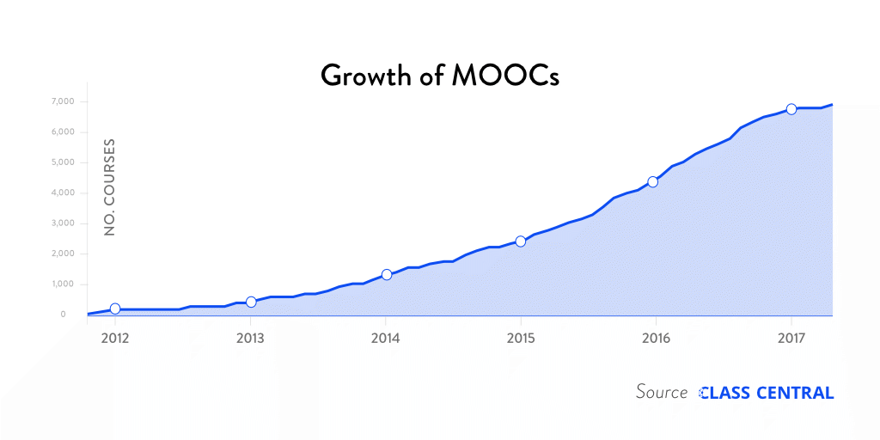

As MOOC’s are exponentially growing need to provide a structured format is a necessity.

**3. Market timeliness**

There is currently no competitor in this market so this is certainly the best time to enter in

this kind of market as the growth rate also looks very good for the development in next five years.

**4. Industry/market feasibility**: Feasible

***5.* Suggestions for improving industry/market feasibility.**

Targeting smaller groups of customers such as only “students and working professionals” at the initial period of start-up would help you improve the feasibility as well as improve the quality of service.

**PART 3: ORGANIZATIONAL FEASIBILTY**

***ISSUES ADDRESSED IN THIS PART***

A. Management prowess

B. Resource sufficiency

C. Conclusion

***ASSESSMENT TOOLS***

***A. Management prowess Assessment***

|  |  |  |  |  |
| --- | --- | --- | --- | --- |
| **S NO.** | **TYPE** | **LOW POTENTIAL** | **MODERATE POTENTIAL** | **HIGH POTENTIAL** |
| 1 | Passion for the business idea |  |  | High |
| 2 | Relevant industry experience | None |  |  |
| 3 | Prior entrepreneurial experience | None |  |  |
| 4 | Depth of social and professional networks |  | Moderate |  |
| 5 | Creativity among management team members |  |  | High |
| 6 | Experience and expertise in cash flow management |  | Moderate |  |
| 7 | College graduate |  |  | Graduated or are currently in college |

***B. Resource sufficiency Assessment***

|  |  |
| --- | --- |
| **RATING** | **RESOURCE SUFFICIENCY** |
| 4 | Office space |
| 4 | Lab space, manufacturing space, or space to launch a service business |
| 4 | Contract manufacturers or outsource providers |
| 3 | Key management employees (now and in the future) |
| 3 | Key support personnel (now and in the future) |
| 3 | Key equipment needed to operate the business |
| 4 | Ability to obtain intellectual property protection on key aspects of the business |
| 3 | Support of local and state government if applicable for business launch |
| 3 | Ability to form favourable business partnerships |

|  |  |
| --- | --- |
| **RATING** | **TYPE OF PROXIMILTY** |
| Neutral | Proximity to similar firms (for the purpose of knowledge sharing) |
| Strong | Proximity to suppliers |
| Strong | Proximity to customers |
| Weak | Proximity to a major research university (if applicable) |

***C. Conclusion***

1) Management prowess

The Management team of ‘PadhoMitro’ consists of passionate budding entrepreneurs having expertise in the field of Software Engineering. One of the Co-Founders, Yash Vaidya, who has a specialization in the field of Web Application Development and has played a key role in the development of the platform, fits perfectly in the role of CEO of the company. Rishabh Kandoi, another Co-Founder and COO of this online platform, has a long experience of team management and has been assigned as the Project Manager in many of the Projects undertaken by him in the past. Shailesh Mohta, CTO and Co-Founder of ‘PadhoMitron’ has served in the IT Industry for more than a decade and has been awarded for providing the most innovative solutions to some of the projects undertaken by him in the past. Along with Renuka, Abhimanyu and Tushar leading the PR and Marketing Department of the company and having a firm understanding of the market, a team of such passionate entrepreneurs and IT Professionals will definitely make ‘PadhoMitro’ a Unicorn Start-up within few years down the line.

2) Resource sufficiency

* **Availability of affordable office or lab space.**

Under the ‘Start-up India’ Scheme of the Govt. Of India, support is being provided to Tech Start-ups like ‘PadhoMitro’ in terms of Working Space, Funding and Registration support.

* **Likelihood of local and state government support of the business.**

Since, our Start-up is a Tech-Start-up and is working to solve problems in the field of education, we can have the local Govt. supporting our idea under the scheme of ‘Start-up India’ along with the support of various local Incubators that support and nurture such ideas.

* **Quality of the labour pool available.**

In order to ensure the maintenance and Development of our Platform, we will hire a few Engineers having background in the field of CSE, IT and even ECE. We shall also collaborate with Payment Gateway Service provider ‘PayU’ and the platform will be secured by a team of System Engineers and Security Experts from the domain of Cyber Security.

* **Proximity to key suppliers and customers.**

Since our Company provides an Online platform for our Products/Services, we shall have our headquarters located in any state and depending on the response of the Beta Version of our application we can then work towards providing more convenient service to our customers.

* **Willingness of high quality employees to join the firm.**

Our Start-up has a huge potential to scale up at global level and having an extensive range of customer segment available for our product, high quality employees with a long work experience and expertise in their field of work will definitely be willing to join our company as full time employees.

* **Likelihood of establishing favourable strategic partnerships.**

With facilities like Subscription based membership, we will have to collaborate with multiple Payment Gateway Providers. Also, with an increase in the number of daily users, we will have to increase the size of our Servers and scale our Network Connections. So, there is a great likelihood of establishing favourable strategic partnerships in order for the successful operation of our company.

* **Proximity to similar firms for the purpose of sharing knowledge.**

We will establish our company among the IT hubs of various states in order to ensure quality support from the similar firms for the purpose of knowledge sharing.

* **Possibility of obtaining intellectual property protection in key areas.**

There is a high possibility of obtaining intellectual property protection in key areas like the design and features of our Online Platform, recommendation algorithm and uniqueness of our services in connecting learners with potential employers, mentors and like-minded peers.

3) Organizational feasibility: ***Feasible***

4) Suggestions for improving organizational feasibility

Since, the Management team has limited experience, more focus towards gaining mentorship and advice from experienced entrepreneurs is recommended and further improvements in the product based on customer reviews is also suggested.

**PART 4: FINANCIAL FEASIBILITY**

***ISSUES ADDRESSED IN THIS PART***

1. Total start up cash needed
2. Financial performance of similar businesses
3. Overall financial attractiveness of the proposed venture
4. Conclusion

***ASSESSMENT TOOLS***

***A. Total Start-up Cash Needed Assessment***

|  |  |
| --- | --- |
| **CAPITAL INVESTMENTS** | **AMOUNT(monthly)** |
| Property | 50,000 |
| Furniture and fixtures | 50,000 |
| Computer equipment | 5,00,000 |
| Other equipment | - |
| Vehicles | - |

|  |  |
| --- | --- |
| **OPERATIONAL EXPENSES** | **AMOUNT(monthly)** |
| Legal, accounting, and professional services | 40,000 |
| Advertising and promotions | 10,000 |
| Deposits for utilities | 10,000 |
| Licenses and permits | 12,000 |
| Prepaid insurance | - |
| Lease payments | - |
| Sales and wages | 25,000 |
| Payroll taxes | 20,000 |
| Travels | - |
| Signs | - |
| Tools and supply | - |
| Starting Inventory | - |
| Cash (working capital) | 50,000 |
| Other Expenses 1 | - |
| Other Expenses 2 | - |
| Total Start-up Cash Needed = | 7,67,000 |

***B. Financial Performance of Proposed Venture to Similar Firms***

**Coursera** is a venture-backed, education-focused technology company focusing on similar business like us. It is a company founded by Stanford professors, it is a platform that offers online courses on different domains and subject. There are several similar businesses more such as edx, Udemy and Udacity, but we have compared our financial performance with the coursera company.

**ANNUAL SALE**

|  |  |  |
| --- | --- | --- |
| **S NO.** | **ESTIMATE OF PROPOSED VENTURE’S** | **EXPLANATION OF HOW THE ESTIMATE WAS COMPUTED** |
| 1 | **Estimate of Year 1 Sales:** 80 million dollars  **Summary:** The proposed annual sales, on average, compares to similar firms: Above Average | On basis of starting inventory and funding received. |
| 2 | **Estimate of Year 2 Sales:** 100 million dollars  **Summary:** How proposed annual sales, on average, compares to similar firms:  Above Average | Prediction based on their previous year revenue. According to times high education it’s the world’s largest MOOC provider hence its annual sales is above average |

**NET INCOME**

|  |  |  |
| --- | --- | --- |
| **S NO.** | **ESTIMATE OF PROPOSED VENTURE’S** | **EXPLANATION OF HOW THE ESTIMATE WAS COMPUTED** |
| 1 | **Estimate of Year 1 Net Income:** 50 million dollars  **Summary:** The proposed annual sales, on average, compares to similar firms: Above Average | On the basis on financial statements. |
| 2 | **Estimate of Year 2 Net Income:** 60 million dollars  **Summary:** How proposed annual sales, on average, compares to similar firms:  Above Average | On the basis of financial statements. |

***C. Overall Financial Attractiveness of Proposed Venture Assessment Tool***

|  |  |  |  |  |
| --- | --- | --- | --- | --- |
| **S No.** | **PARAMETERS** | **LOW POTENTIAL** | **MODERATE**  **POTENTIAL** | **HIGH POTENTIAL** |
| 1 | Steady and rapid growth in sales during the first one to three years in a clearly defined target market | Unlikely | Moderately likely | Highly likely |
| 2 | High percentage of recurring income- meaning that once you win a client, the client will provide recurring source of revenue | Low | Moderate | Strong |
| 3 | Ability to forecast income and expenses with a reasonable degree of certainty | Weak | Moderate | Strong |
| 4 | Likelihood that internally generate funds will be available within two years | Unlikely | Moderate likely | Strongly likely |
| 5 | Availability for exit opportunity for investor (if applicable) | Unlikely to be unavailable | May be available | Likely to be available |

***D. Conclusion***

From the above results of the feasibility analysis, we obtain information regarding the total cash that is required to start our business, by comparing the financial performance of the similar business such as Coursera which provides MOOC for several courses, it is clear that this business have good scope in the market. Hence the product provided is feasible.

**PART 5: OVERALL FEASIBLITY (SUMMARY AND CONCLUSION)**

|  |  |  |
| --- | --- | --- |
| **TYPE OF FEASIBILTY** | **OVERALL FEASIBILITY** | **SUGGESTION FOR IMPROVING FEASIBILITY** |
| Product/Market Feasibility | Feasible | Changes in product need to be done based on customer reviews |
| Industry/Market Feasibility | Feasible | Identifying a segment of users that would use our product most frequently |
| Organizational Feasibility | Feasible | The management teams should seek mentoring from experienced entrepreneurs |
| Financial Feasibility | Feasible | Identifying opportunities to raise capital in the early stages of the product |
| Overall Assessment | Feasible |  |

**CONCLUSION**

Our venture, “PadhoMitro” is well accepted in our target market and financially feasible. With our management prowess and resource sufficiency, we can successfully launch our business.

Also, on comparing our venture with similar other products/services in the market, we have the following USBs that gives us an edge over them.

1) Free subscription in case of no one-to- one mentorship chosen.

2) Full-time Dedicated Mentorship support, in-case of subject/Project related queries

3) A customized road-map to make the user self-sufficient to master a subject without the need to browse the internet.

4) Links to potential recruiters of user’s field of study thus saving them from hunting for internship/job opportunities.

According to our reports and findings,

73.6% of the total number of people desire our service.

61.8% of the total number of people demand our service.

62.8% of the total number of people think our venture is feasible.

The result obtained from various surveys and overall analysis of all the factors leads us to determine that our product is feasible in the market and can be successfully be developed and converted into a Start-up. Some suggestions however, needs to be addressed in terms of product features and scope of our product. Overall assessment of the product is its feasibility to sustain and scale in a wide range of customer segment. There is a strong need for developing digital platforms to enhance the process of teaching and learning and while such transformations are already taking place there is still a need for the correct guidance and track that every learner needs to follow in order to achieve the desired target or goal. With this product, the process of self-learning will become more convenient for the learners and it will be more time saving and economic for anyone interested to learn new things.